**TRAINING POLICY**

# TABLE OF CONTENTS

1. **INTRODUCTION**
   1. **OBJECTIVE**
   2. **SCOPE**
   3. **ROLES AND RESPONSIBILITES**
2. **PROCESS**
3. **RACI**
4. **FLOW CHART**
5. **DISCLAIMER**

|  |  |  |  |  |
| --- | --- | --- | --- | --- |
| **DOCUMENT REVISION HISTORY** | | | | |
| **Release Version** | **Modified Date** | **Modified** | **Changes** | **Approval Authority** |
| 2.0 | 01-11-2019 | Training Department | Training process document and guidelines | Head, HR |

1. **INTRODUCTION**
   1. **OBJECTIVE**

To establish, implement, maintain and continually improve the training process, for people development.

* 1. **SCOPE**

All employees of Supremology Technologies, India. This process covers all the activities involved in the people training process, including training need identification, providing training and evaluating trainings provided.

* 1. **ROLES AND RESPONSIBILITIES**

### Training Co-Ordinator

1. Assess training needs for all employees and prepare training plan
2. Identify internal and external training programs/ trainers and choose appropriate training methods
3. Organize internal training programs
4. Organize external training programs
5. Manage & maintain the training records
6. Handle logistics for training activities including venues and equipment
7. Establish and maintain relationships with external training suppliers
8. Creating the course in the LMS tool and assign the course to nominees
9. Coordinate off-site training activities for employees

### Trainee

1. Have a positive attitude and behave in a professional manner
2. Attend all training programs you are nominated for
3. Be part of the productive process within the framework of being trained
4. Demonstrate initiative and drive in a quest to learn from the training programs
5. Mark attendance through QR code and provide feedback on the training offered and the trainer

### Trainer

1. Design and Customize the training content based on our requirements.
2. Deliver the training programs requested.
3. Have the skills needed to handle difficult participants?
4. Respect client confidentiality during training/ workshop presentations and advise trainees to do the same.
5. Present information in such a way that trainees can use it to increase their knowledge base.
6. Present activities that will reinforce the learning process.
7. **PROCESS**
   1. **IDENTIFICATION OF TRAINING BUDGET**

The Delivery Unit Heads will identify and share the organizational training budget for the year for their respective business units. Finance department allocates the budget.

* 1. **IDENTIFICATION OF TRAINING NEEDS**

Needs Training needs are identified during the

1. Appraisal process
2. Ongoing Project needs
3. Business Plan/ Business Strategy

The objective is that each employee from the operations shall undergo training to update their skills and to acquire the required competency to perform as per the Organizational performance expectations and client needs.

* 1. **Training Plan**

The Training and Development department shall summarize the training inputs derived from the above process into an Annual Training Calendar/ Planner. The annual training calendar/ Planner will not include any unplanned trainings like Seminar, Product demo, etc. Any unplanned trainings/seminar must be approved by the Delivery/Department Heads and submitted to the Training and Development Department.

* 1. **TRAINING REGISTRATION PROCESS**

For every external training, and any internal training that involves cost must be approved by the respective Delivery Unit Heads. Training Waiver can be granted to employees on the following grounds

1. Due to the knowledge and skills acquired through previous course work or work experience.
2. Due to changes in the project requirements.

Exemptions may be granted to employees at the discretion of the Delivery and Department Heads for completed equivalent courses, professional experience or Training programs.

* 1. **IDENTIFICATION OF TRAINER**

An extensive search is made by Training and Development team to finalize the trainer who will conduct the set training. The trainer will be from an external training agency or internal. Supremology evaluates an external trainer based on parameters like how experienced the trainer is, clientele list where the training is imparted, cost effectiveness, availability, etc. Based on the inputs a decision is made to register the trainer with Supremology.

In some cases, internal trainer is available to conduct the training sessions. Supremology evaluates the internal trainer based on his/her level definition in the Competency matrix. Only if the employee is identified as an Expert against a specific knowledge/skill/process they will be entitled to conduct the training. In case he/she is not identified as an expert then an email communication stating his eligibility to conduct trainings internally, shall be obtained from his immediate manager.

* 1. **TRAINING EXECUTION**

The email is sent out to the Delivery/Department Head’s with the details of the training scheduled as per the training plan, requesting for nominations. The recommended employee list is fetched, and an email is sent to all the nominated employees on the details of the training and schedule in order to attend the training. And the course will be assigned to nominated employees in the LMS tool

* 1. **TRAINING ATTENDANCE**

Participants mark their attendance by scanning QR code after completion of the training for the assigned course. In- case any participant has technical issue to login LMS tool, attendance will be captured manually by L&D coordinator. In case there are any absentees with prior information the same shall also be brought to the notice of the immediate superiors and department head. There is no provision for attendance sheet for public batches and self-paced E learning in the LMS tool.

* 1. **TRAINING FEEDBACK**

A training feedback will be triggered to the participants immediately after marking attendance. Feedback option triggers in the mobile application and web as well. The feedback form captures the participant’s opinion about the training content/presentation, trainers and the resources provided during the training program. There is no provision of feedbacks for self-paced E learning courses.

* 1. **TRAINING EFFECTIVENESS**

On completion of three months of each training, the training effectiveness is measured. This is done through the mail to managers for providing effectiveness feedback through share point survey. A questionnaire is initiated to collect the inputs on measuring the training effectiveness. Training effectiveness is only for competency enhancement training and not for seminars and conferences. In-case of the effectiveness rated by participants/ manager is below average then the trainer is being asked to deliver the training to close the gaps. There is no provision of effectiveness feedbacks for self-paced E learning courses.

* 1. **KPI OF L&D DEPARTMENT**

By the end of calendar year, L&D department should complete the trainings requested by respective teams, which are planned after based on the approval for cost by the concerned delivery head. i.e. Completed Trainings/Planned Trainings = 100%. Any trainings pushed to the next year due to the expense freeze or due to avoidance of billing loss, would be exempted from Planned Trainings.

The average training feedback and training effectiveness score should be more than or equal to 3.5 on the scale of 5.

* 1. **TRAINING RECORDS**

Training records are stored in physical/ digital folder structure based on the type of the record/ document. These folders are access controlled. Only Training department personnel has access. However minimum 3 years of data shall be maintained.

# RACI

|  |  |  |  |  |  |  |  |  |
| --- | --- | --- | --- | --- | --- | --- | --- | --- |
| **Activity** | **CEO** | **Delivery Head** | **Delivery Manager** | **CT O** | **Training Coordinator** | **Trainer** | **Finance** | **Trainee** |
| Identification of Training Budget |  | A, R |  |  | C |  | A,R |  |
| Identification of Training Needs |  | C | C |  | A,R |  |  | C |
| Training Plan | C | C |  |  | A,R |  |  |  |
| Training Registration Process |  | C |  |  | A,R |  |  |  |
| Identification of Trainer |  | C |  |  | A,R |  |  |  |
| Training Execution |  | A | R |  | C |  |  | I |
| Attendance |  | I | I |  | A |  |  | R |
| Training Feedback Analysis |  | I | I |  | R |  |  | A |
| Training Effectiveness |  | A | R |  | I |  |  |  |
| Design & Deliver Training Program |  |  |  |  |  | R |  |  |

# FLOW CHART

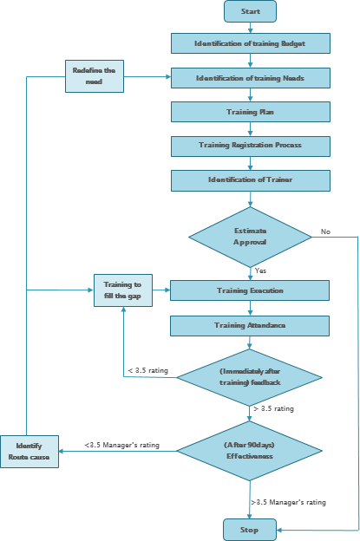

# DISCLAIMER

This policy and its contents are confidential and intended solely for the use by employees of Supremology Technologies India Pvt. Ltd. Transmitting, Disclosing, Copying, distributing these contents to other than the intended recipient / users are strictly prohibited. It is the sole discretion of the Management to change, amend the entire policy and/or its clause/s from time to time and/or withdraw the same, without any notice. This policy supersedes all earlier versions if any